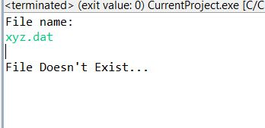

In this picture, a non-existent file was entered into the console and displays an error as a result.

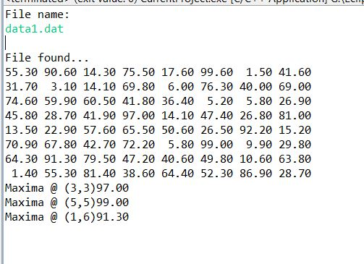

In this picture, an existent file was found and was read into an array and printed to the screen. Then a function goes through the array and finds maximums in the array and prints them out as shown above.